How to People When You Just Can’t People No More: An Introverted Advisor’s Guide to Faking It
Brenda Fuhr and Katie Honomichl – University of Central Missouri

Susan Cain’s Quiet Quiz: https://tinyurl.com/y4uullk7
Take time to fill out this as you complete the quiet quiz for your own self-reflection. You will not be asked to share unless you want to do so.
Flash Writing Prompts
- Before I took the quiz I thought I was a:
- After the quiz it said I was a:
- Did this surprise your or not? Why?

Are you bored? Here is some things to keep you with us.
What are some words associated with your introvert/extrovert/ambivert self that you enjoy? Bristle at? Or find weird?

Think about an instance that you felt that you were not only burning yourself at one end but both ends of your candle. What could have been a help to your stressors?

Conversation Starters for the Student, Different-vert, or Faculty in your life.

- Think about a time that you were with back-to-back student appointments in your peak season. Your energy was low and a student commented that you seemed down. How would you respond and engage them?

- Think about a frustrating encounter with a colleague who you now understand is different in how they gain energy (vert!). How would you reword or re-engage your coworker to come to a solution together?

- Think about a moment of miscommunication with an advisor or faculty member. How would you take stock of the situation and work on how to best communicate with each other?

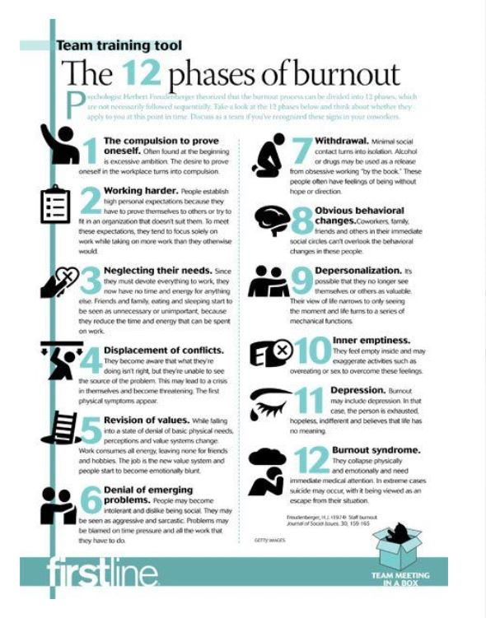Source: http://veterinaryteam.dvm360.com

